Community Analysis Scan
Of Ohio County, Indiana
In order, to give a general summary of Ohio County the following came from Wikipedia: “Ohio County is bordered by Dearborn County to the north, across Laughery Creek which forms the border between the two counties. A short portion of the western border, less than 2 miles (3.2 km) long, is shared with Ripley County to the northwest. Switzerland County lies to the south, and Boone County, Kentucky lies across the Ohio River to the east. According to the 2010 census, the county has a total area of 87.43 square miles (226.4 km²), of which 86.14 square miles (223.1 km²) (or 98.52%) is land and 1.29 square miles (3.3 km²) (or 1.48%) is water.^{[11]}The County’s sole incorporated settlement is the city of Rising Sun, which is located in the Far East part of the county on the banks of the Ohio River.” (https://en.wikipedia.org/wiki/Ohio_County,_Indiana)

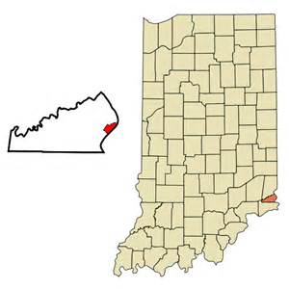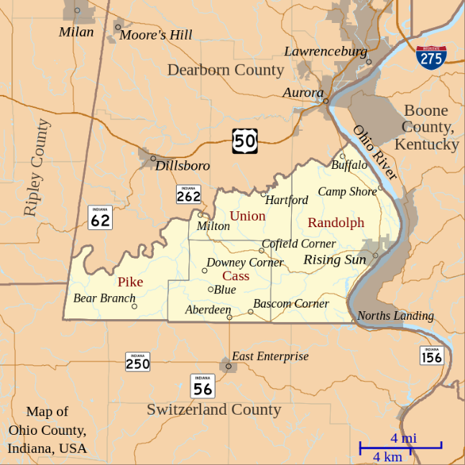

According to the United States 2020 Census Bureau, Ohio County’s population is 5,978.

Range of Ages of People living in Ohio County
 | Percentage of Population
Less than 5 years old | 5.0
Under 18 | 20.1
Between 18& 64 | 52.1
Age 65 & over | 22.8

Households in Ohio County
Type of households | Number of households
Total households | 2,623

(http://www.census.gov/search-results.html?q=Ohio+County%2C+IN&page=1&stateGeo=none&searchtype=web)

There is minimal racial diversity in Ohio County.
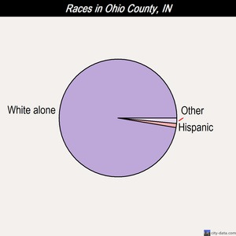

Races in Ohio County, Indiana:
- White Non-Hispanic Alone (97.2%)
- Black (0.8%)
- American Indian (0.3%)
- Hispanic or Latino (2%)
- Two or more races (1.4%)
Median resident age: |  | 47.8 years
Indiana median age: |  | 38.0 years
Males: 2,952 | 49.8%
Females: 2,980 | 50.2%
Religion in 2010
None 71.2%
Evangelical Protestant 17.4%
Mainline Protestant 11.3%

2020 Election
Biden (21.7%)
Trump (66.8%)
Other (11.5%)

Earthquake activity
Ohio County area historical earthquake activity is significantly above Indiana State average. It is 66% greater than overall U.S. average.
(http://www.city-data.com/county/Ohio_County-IN.html#ixzz4YD12lBbs)

Ohio County Employment
The three largest employers in Ohio County are Rising Star Casino, Rising Sun-Ohio County School Corporation and local governmental entities. However, the casino industry is always in flux, which creates a concern locally about the closing of the casino in Ohio County. The state controls the funding of the school and since 2007 our school system has experienced budget cuts from the state year after year. Due to these budget concerns there were concerns about closing down the schools locally and busing the students to the neighboring counties. Even though a local school funding referendum was passed overwhelmingly that raised local taxes. Local government depends on the riverboat revenue for many jobs that have been added since the river boat gaming. So, if the casino leaves a lot of the government jobs would be lost, as well.

The unemployment rate for Ohio County is 2.6 % (https://data.bls.gov/map/MapToolServlet).
The median family income for Ohio County is $63,649 with 9.8% below the poverty line.
(http://www.census.gov/search-results.html?q=Ohio+County%2C+IN&page=1&stateGeo=none&searchtype=web)
This community does not experience a large influx of population during different seasons.

Ohio County Community Profile
 | yes | no
Newspaper |  | x
Radio Station |  | X
Television Station |  | X
Bookstore |  | X
Video Store |  | X
Music Store |  | X
Internet Providers | 3
School Library | 2
Academic Library |  | X
Hospital/Medical Library |  | X
Legal Library |  | X
Special Library |  | X
Public Library | 1
Preschools | 2
Elementary/Middle School | 1
High School | 1
Vocational School |  | X
Colleges |  | X
Hospitals |  | X
Clinics | 1
Rehabilitation hospitals |  | X
Hospices |  | X
Nursing Home | 1
Senior Housing | 1
Day Care Center for Adults |  | X
Child Care Services |  | X
Chemical Treatment Center |  | X
Youth Centers |  | X

Ohio County Organizations and Government Offices
There are 10 churches in Ohio County. The kids can be members of a local 4-H club; however, the numbers are dwindling, due to less family farms and year around traveling sports. Ohio County has an active Legion Post #59. There is only one fraternal organization; the local Lions Club. In the City of Rising Sun, the County Government offices are held. There is a State Bureau of Motor Vehicles with limited hours. There are no Federal Government Offices in the county.
Five Important Issues Facing Ohio County in Next Five Years
- School success. If the state continues to make cuts to our local school budget. Without the school, the county worries families will move out of the community to be closer to the schools, they would be forced to attend. The library would be affected by this change in demographics. It will then be the only library in the county.
- The casino business directly affects the community. It is the largest employer and pays the most taxes. Its’ viability is always an important issue and the future is not always bright. This affects the library due to the property taxes they receive for their operating budget.
- The City of Rising Sun has been trying to market the city as a “retirement community”. As one can see the demographic of active retirees are the largest part of the community already. The library is currently set up to be of assistance to this demographic, but it could mean even more opportunities for volunteers and programming that active retired seniors would enjoy.
- We wish Ohio County was immune to the drug problem; however, we have our share of drug misuse in our community. We have seen this a lot in the library with increased supervised visits for parents who have lost custody of their children and grandparents raising grandchildren.
- Trying to find new and inventive ways to help the underserved with the economy and inflation taking its toll on our nation after the pandemic, we see a lot more people struggle to survive.

Bibliography

Bureau of Labor Statistics-Ohio County, Indiana. (n.d.). United States Department of Labor. Retrieved by https://data.bls.gov/map/MapToolServlet
Ohio County, Indiana. (2017) City-data.com. Retrieved from http://www.city-data.com/county/Ohio_County-IN.html#ixzz4YD12lBbs
Ohio County, Indiana. (2017) United States Census Bureau. Retrieved from http://www.census.gov/search-results.html?q=Ohio+County%2C+IN&page=1&stateGeo=none&searchtype=web
Ohio County, Indiana. (2016). Wikipedia. Retrieved from https://en.wikipedia.org/wiki/Ohio_County,_Indiana

Mission Statement
Our Mission is to serve the educational, informational and recreational needs of the residents in Ohio County.
Methodology
The Long-Range Planning Committee of the Board of the Trustees were presented with ideas and allowed to expand or extract from them as they saw fit. The community was asked to provide suggestions and goals they would like to see the library achieve over the next 5 years. There was a suggestion box at the front desk where free pens were given if a suggestion was made. It was also asked on the Library’s FaceBook page. The Committee reviewed the material themselves and got the opinions and feedback from other members of the community. The findings from the Committee were reviewed, a draft was prepared by the Director, the Committee edited the draft, and the Board of Trustees voted to approve the final plan.

Goals and Objectives
GOAL 1: To continue and find more ways to partner with the local schools to aid our shared success.
The library and schools work together to help the school with the summer and break camps. The camp kids use the library to check out books, legos for activities, and are read to by staff on occasion.
GOAL 2: To continue to establish and maintain a collection of books and materials in a variety of formats, to meet the informational and recreational needs of the community.
For our local demographic the printed book continues to be the primary medium for reading, not only the printed book, but large print books have gained more popularity as our community ages. We have more older citizens than young ones. However, the library needs to stay aware of the demographic trends for when there is a change. The library needs to stay aware of and adapt their collection to new technologies. We are pleased to report in 2022 we are now a member of Libby. The app that allows patrons to borrow audiobooks, ebooks, and magazines. We will continue with this because it has been appreciated. We got many new patrons once we got the Libby app. Thanks to the state for finding a way to make it affordable even to us.
Objective: Continue to update and acquire new material that will be best suited for our community.
Objective: Continue to explore and research new products that may be a good fit for our community like Libby.
Objective: Continue to write grants to help pay for newer technology and large print books.

GOAL 3: To be aware of the largest growing population of our community which is older citizens.
We have been aware of this and purchase large print and audio books when we receive grant funds. They are hit with these patrons.
Objective: Continue to be aware of how our community is growing and changing
Objective: Create programming and recruit volunteers from this growing demographic, we have a successful 3 day a week chair yoga program that has a loyal following.
Objective: Find programming that active seniors will enjoy and attend.
GOAL 4: To be aware of the affects drug use is having on our community and what we can do to help the victims
We are not immune to the drug problem that is plaguing our country. We have more grandparents raising grandchildren, more supervised visits in the library, and more emotionally challenged patrons from this.
Objective: Make safe programming available to the youth
Objective: Create a safe environment for the community
Objective: To have helpful material and resources for those in need
Objective: To have Naloxone in the library in case of an emergency
GOAL 5: Find new and inventive ways to help the underserved.
Objective: Create a seed library for people who experience food scarcity and flower seeds to encourage all to get outside and be with nature to help our mental health.
Objective: Partner with local not for profit to get school supplies and backpacks to people in need
Objective: Do StoryWalks at our parks to remind and encourage people they have a public library.
Objective: Have a well-known Tri-State Artist create a mural in our library, we have many people in our community who have limited transportation so let’s bring art to them. We are worthy of pretty and creative experiences.
Evaluation process for our goals will be an annual evaluation.

The Ohio County Public Library building was built in 2007. All six heating and air conditioning units were replaced in 2021-2002. All is well with the current building just servicing and maintaining what we have. We have had conversation with the architect, Harry Mulher, to help us create a safer environment for our staff. The way the front desk and offices are located, if our library was to have an active shooter our staff would have zero exits. Other than this we have no plan of renovation or updating except fixing what breaks.

The Ohio County Public Library has become financially conservative. We only have one full time person. The director does everything from order books, catalog, cover books, shovel sidewalks, marketing, social media accounts, pull weeds, writes grants, programming, accounting, you name it she does it. The library is able to operate fully with their funds from property tax now with one full staff member and 3 part time (less then 20 hours a week per staff member). The part time staff only work front desk and shelf, so they do not get LEUs. Our director gets her LEUs from the annual conference and webinars. Since the library has saved so much money on payroll, they put funds in a Rainy-Day account with TRUSTIndiana. The library years ago got a large donation from a community member that money has been moved to TRUSTIndiana, as well. We do have a casino in our county, but we are never guaranteed any money. However, in the fall each year we have received checks for around $7,000-$8,000 from the City of Rising Sun. We have some endowments at the local foundation that the board typically reinvests every year because it is not much money and allowing it to grow.
Professional development strategy.
Director goes to the annual library conference and watches webinars. Part time staff has no training besides how to shelf. They do not have any responsibilities beyond checking out and shelving.

